Matter Center for Office 365

Build and deployment guide

Table of contents

Pre-requisites 2

Deploy SharePoint Assets 6

Deploy Azure Resources, Office and exchange Apps 11

13

Appendix A 13

Adding new client to the Tenant 13

Appendix B 34

Publish Content types from Content Type Hub 34

Appendix C 36

Add admin account to term store admin 36

Troubleshooting Deployment Issues 37

## Pre-requisites

**Office 365 and Azure requirements**

| **Infrastructure** | **Service Accounts** | **Comments** |
| --- | --- | --- |
| Plan | - | Purchase Office 365 Enterprise E3 plan:  <https://products.office.com/en-us/business/office-365-enterprise-e3-business-software>  Other plans:  <http://office.microsoft.com/en-us/business/compare-all-office-365-for-business-plans-FX104051403.aspx> |
| Domain (optional) | Admin account | Domain for O365 portal  If you already have the domain that will work with Office 365, please add same through admin portal  Otherwise Purchase and register domain |
| SSL certificate (optional) | - | Purchase and configure trusted authority certificate for domain |
| Active Directory Integration (optional) | Admin account | Setup and synchronize existing Organization Active Directory on O365 portal  <http://technet.microsoft.com/en-us/library/hh967642> |
| Exchange Online (optional) | - | Configure Exchange 2013 with latest service packs |
| Azure Subscription |  | Purchase Azure subscription which will be used to host 1 web sites  Matter Web App |
| Domain and certificates (optional) | - | Domain & certificate for UI layer (website on azure)  Purchase and configure domain with website on Azure  Purchase and configure trusted authority certificate for domain |

**Configurations**

| **Infrastructure** | **Service Accounts** | **Comments** | **Client** |
| --- | --- | --- | --- |
| Office 365 tenant | Service account with admin rights to be able to:   1. Setup App catalog 2. Add Office apps in app catalog 3. Add mail apps at Organization\Individual level in Exchange Online 4. Admin access on term store to add Organizational metadata 5. Add Crawled\Managed properties 6. Create site collections for client 7. Create config lists in catalog site 8. Setup content type hub   Exchange service account that will be used to generate mail on the fly for mail cart functionality  **Note:**   1. Service account represents a single account to be used throughout the process 2. Whenever a new client is added to the system, you can follow the steps mentioned in Appendix A for properly setting up the client | Following things should be available or created manually:   1. App Catalog   **Note:** Steps to create App catalog is present in Step 1 of deployment steps   1. Organizational metadata hierarchy (Client detail, Practice group & hierarchy)   **Note**: Corresponding term set groups should accordingly be updated to Excel config file   1. Client site collections and updating clients taxonomy details 2. Adding Content types, publishing same and   updating corresponding taxonomy details  Also Exchange service account details should be added to Matter Center Deployment Configuration Excel | Outlook 2013, Office 2013,  Exchange 2013,  IE 10+ |
| Azure Subscription | 1 account with admin rights to deploy and maintain build. This same account should have Admin permission on 0365 tenancy | **Azure**:  This subscription will be used to deploy Web site, Web service and maintain error logs. Hence we will require a subscription which has following:   1. Web role 2. Azure Storage |  |

**Other requirements:**

1. For mail cart functionality on Matter Center Home page, we will require a service account to generate the e-mail with attachments on the fly and to ensure that the mail will be deleted from drafts once sent
2. **Note**: If there is a change in password of account used, you can follow steps mentioned in Appendix B to update it for Matter Center
3. For a brand new Office 365 tenant subscription, the account being used for deployment needs admin access to the Term Store in the SharePoint admin center
4. Below are the pre-requistes for running the scripts on the user’s machine:

* [SharePoint Online Management Shell](http://www.microsoft.com/en-us/download/details.aspx?id=35588)
* [Windows PowerShell](https://www.microsoft.com/en-us/download/details.aspx?id=50395)
* Run ‘Install-Module AzureRM -AllowClobber’ from Windows PowerShell
* [Visual Studio 2015 (Community or Pro and above)](https://www.visualstudio.com/en-us/products/vs-2015-product-editions.aspx)
* [.NET Core](https://www.microsoft.com/net/core#windows)
* [Azure SDK](https://go.microsoft.com/fwlink/?LinkId=518003&clcid=0x409)
* [Office Developer Tools for VS 2015](http://www.microsoft.com/web/handlers/WebPI.ashx?command=GetInstallerRedirect&appid=OfficeToolsForVS2015)

1. Restart the system after installing above pre-requisites
2. Use English (code 1033) SharePoint Online sites for initial deployment.
3. We are using powershell scripts for deployment, sometimes the scripts are not allowed to execute on the machine, we can follow below steps to allow execution of the script:

* Unblock all PowerShell scripts and DLL files by unblocking mattercenter-master zip file in Windows Explorer (right-click -> Properties -> checkmark: Unblock -> OK)
* Open PowerShell.exe in administrator mode
* Type the following command: Set-ExecutionPolicy “RemoteSigned”, it will ask for confirmation then type “Y” for yes.

## Deploy SharePoint Assets

| # | **Deployment Steps/Description** | **Automated/Manual** |
| --- | --- | --- |
| **Step 1** | **Office 365 - Create App Catalog**  **Steps to create App Catalog site:**   1. Sign in to the Office 365 admin center with your SharePoint Online admin user name and password 2. Go to Admin > SharePoint 3. Click Apps on the left, and then click App Catalog      1. Select **Create a new app catalog site**, and then click OK      1. On the Create App Catalog Site Collection page, enter the required information, and then click OK     Once the App Catalog site is created, you can navigate it within the SharePoint admin center by clicking Apps >App Catalog. The App Catalog site will have a document library for Apps for Office and a document library for Apps for SharePoint, as well as a list that tracks App Requests from site users. |  |
| **Step 2** | Add admin account to term store administrators, for adding account to term store administrators refer Appendix C | Manual |
| **Step 3** | 1. Create build of helper utilities    1. Navigate to src\Helper Utilities and open Helper Utilities solution in Visual Studio and build the solution    2. This will build all deployment utilities and copy all EXE and Config files into deployments\scripts\Helper Utilities folder | Manual |
| **Step 4** | Update the configuration values in Excel  **Location:** src/deployments/MCDeploymentConfig.xlsx  **Sheets**: Config, Create_Group, TermStore_Config, Client_Config, Sample_Data  **Note**:   1. For fields that are not applicable for your application should be given the value NA. There should be no fields left blank 2. Close excel sheet after updating. Otherwise deployment script will fail to read excel sheet. | Manual |
| **Step 4** | **Office 365** – Run Setup (Deploy.ps1 PowerShell script)  **Location:** <solution location>/Deployments/Scripts/Deploy.ps1  **Script will create following**:   |  |  | | --- | --- | | # | Item | |  | **Pre-requisite checker**   1. .NET version and installation check 2. IIS version and installation check 3. Excel configuration file existence check 4. SharePoint Online version check 5. Solution file existence check 6. .CSPROJ file existence check 7. Web.config, Web_Cloud.config, Web_OnPremise.config file existence check for two solutions | |  | **Configures permissions to catalog site**   1. Add SharePoint Group 2. Add members/users to Group 3. Assign permission to Group | |  | **Creates Configuration lists**   1. Matter Center Matters 2. Matter Center Roles 3. User Pinned Details (for Documents) 4. User Pinned Matters (for Matters) 5. Matter Configurations (Default values for the client) 6. Matter Center Help Links 7. Matter Center Help Section   **Adds Role details** | |  | **Configures Term store**   1. Client Ids 2. Clients 3. Practice Group -> AOL -> SAOL 4. Setting custom property values    1. Folder Hierarchy    2. Content Type   Document Templates   * 1. Is Folder Structure Present | |  | **Adds metadata to parent content type**   1. Create site columns (predefined site columns are required for apps) 2. Add these site columns to specified parent content type 3. Create additional content types based on inputs in Excel | |  | Activate SharePoint Server Publishing Infrastructure feature on catalog site | |  | Imports search configuration for app Updates app list permissions | |  | Create site collection(s) on SharePoint library based on inputs in Excel, creates Matter Center Restricted groups in each site collection, activates Document ID service feature on each of the site collection and on the tenant root site collection | | Automated |
| **Step 5** | Publish all the created content types along with parent content type  To know how to publish content types, refer to Appendix B | Manual |

## Deploy Azure Resources, Office and exchange Apps

| # | **Deployment Steps/Description** | **Automated/Manual** |
| --- | --- | --- |
| **Step 1** | Build the solution by either pressing F5 or going to Build > Build Solution | Automated |
| **Step 2** | Open Powershell as administrator and navigate to <<download location>>\tree\master\cloud\src\solution\Deployment\Scripts and run Deploy-AzureResourceGroup.ps1   |  |  | | --- | --- | |  | Deploys Office Apps | |  | Deploys Outlook Apps | |  | Adds App to Exchange | |  | Upload files required for Matter landing page, Settings page, Web Dashboard page and Document Details page to SharePoint library  Updates the values of ApplicationInsightsID, URL’s for pages on Azure and links on the page in Matter Landing, SPCommon and Document Details JS file. Also updates the references in the Document Details HTML file | |  | Provision Web Dashboard page(s) and Settings page(s) at tenant level and site collection(s) created in step 15 in this table. Also provision Document Details page on Catalog site. | | Automated |
| **Step 3** | 3a. Specify [office 365 Api permissions](https://msdn.microsoft.com/en-us/office/office365/howto/add-common-consent-manually#register-your-web-server-app-with-the-azure-management-portal) as below.    3b. Run script \tree\master\cloud\src\solution\Deployment\Scripts\keyVaultSecret.ps1 to update secret in keyVault  Refer “[Generate a new app secret for your web application](https://msdn.microsoft.com/en-us/office/office365/howto/add-common-consent-manually#register-your-web-server-app-with-the-azure-management-portal)” section to generate new secret.  3c. Open Microsoft.Legal.MatterCenter.sln in visual studio as administrator and publish Microsoft.Logal.MatterCenter.Web project. Refer “Publish Your Web App” section <https://blogs.msdn.microsoft.com/microsoftimagine/2015/07/20/welcome-to-visual-studio-2015-with-azure/> if you are new to publishing from VS. | Manual |
| **Step 4** | Publish exchange App and office app from visual studio to file location and then upload into office tenant. |  |

# Appendix A

## Adding new client to the Tenant

**Pre-requisite:**

Site collection should already be created.

**Steps:**

1. Term store configuration changes:

* Go to Admin center by typing the following URL in the browser: https://<tenant>-admin.sharepoint.com
* For e.g. <https://mysharepointtenant-admin.sharepoint.com>
* Select “term store” from the left navigation menu.

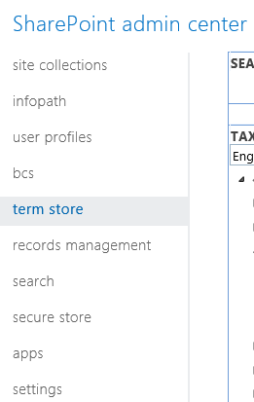

* Expand the Taxonomy node, look for MatterCenterTerms node and expand it
* Right-click on the “Clients” term set and select “Create Term” as shown below:

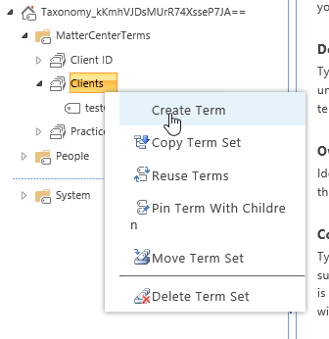

* Enter the name of the Site collection, the term should be created

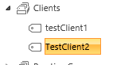

* Now, go to the Custom Properties tab and in the Shared Properties section, select Add
* Enter following values one after other:

|  |  |
| --- | --- |
| **Shared Property Name** | **Value** |
| ClientID | Some number (for e.g. 100002) |
| ClientURL | <Site collection URL> |

* After adding above values, click on save button.
* Right-click on the Client ID term set and then click on create term as shown below:

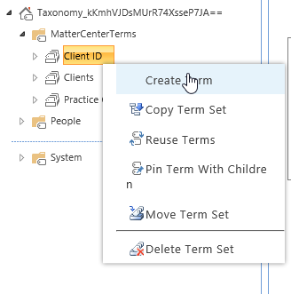

* Enter the number which we previously inserted in above mentioned table.
* The new term should be added as shown below:

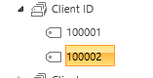

1. Activate Document ID feature on the Site collection:

* Navigate to site settings
* Click on Site collection features

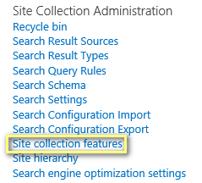

* Enable the Document ID settings feature



* Navigate to Document ID settings tab

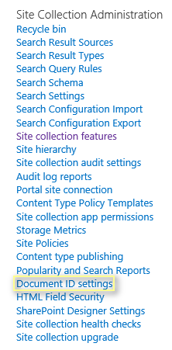

* Enter the details and click OK

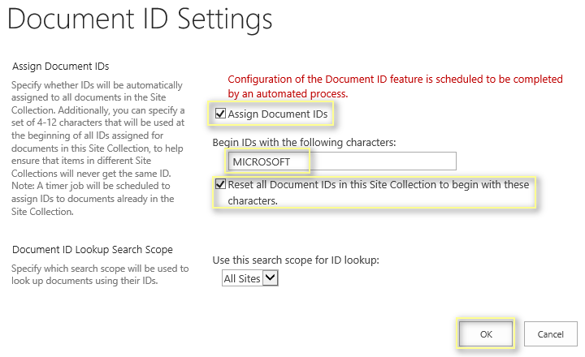

1. Provision Web dashboard page:

* To provision web dashboard at Tenant level
* Navigate to ‘Site contents’ of Tenant

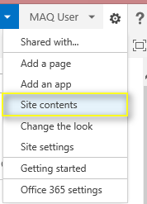

* Navigate to ‘Site Pages’

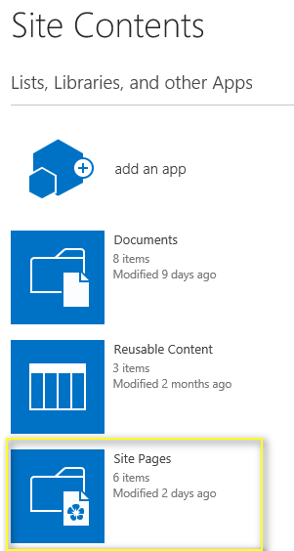

* Update web dashboard URL in ‘WebDashboardSPTemplate’ HTML.

Location for ‘WebDashboardSPTemplate’= “../mattercenter-master/tree/master/cloud/src/deployments/Static Content/HTML/ WebDashboardSPTemplate .html”

* URL should be Azure web dashboard as below:



* Update the catalog URL in script as below:



* Upload following HTML page under ‘Site Pages’
  1. WebDashboardSPTemplate.html
* Create a new page using Wiki template and name it as ‘MatterCenterHome’.

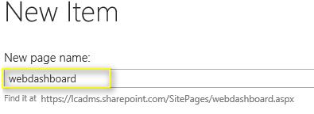

* To create new web part, we have to perform following steps
  1. Add “Content Editor” web part on the page

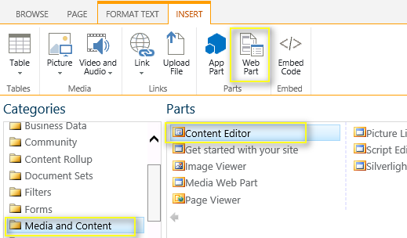

* Configure web part with following settings
  1. Provide URL of “WebDashboardSPTemplate.html” page which was uploaded in Site Pages
  2. Make chrome type as ‘None’

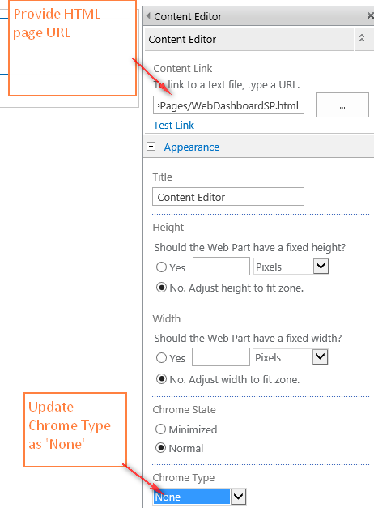

* Click on ‘Save’ button
* Verify that web dashboard is loading fine

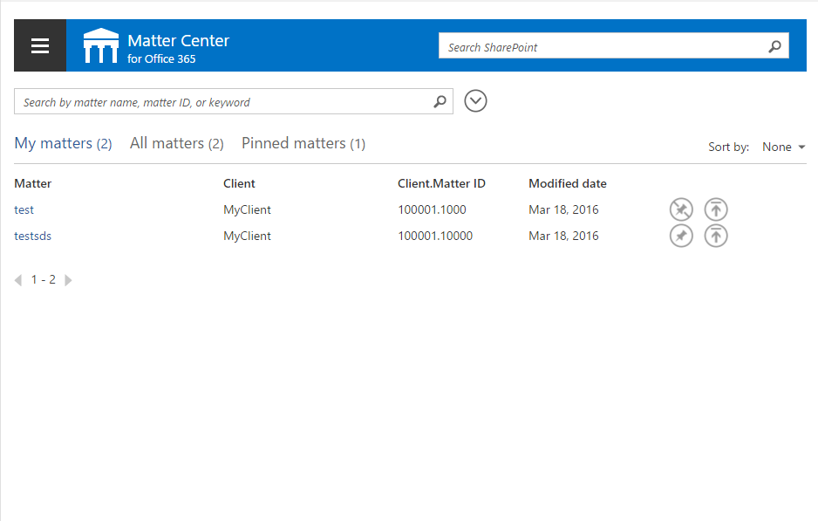

1. Steps for Provisioning settings page at Site collection level:

**Settings page configurations**

* Navigate to the Site collection that was just provisioned

1. Navigate to ‘Site contents’



1. Navigate to ‘Site Pages’



* Update settings page URL in ‘SettingsSP’ HTML.

Location for ‘SettingsSP’ = “../mattercenter-master/tree/master/cloud/src/deployments/Static Content/HTML/SettingsSP.html”

* URL should be Azure settings page as below:



* Update the catalog URL in Script as below:



1. Upload following HTML page under ‘Site Pages’

* SettingsSP.html
* Create a new page using Wiki template and name it as ’Settings’.

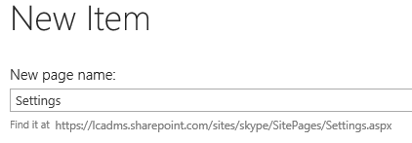

1. To add new web part, we have to perform following steps

* Add “Content Editor” web part on the page



1. Configure web part with following settings

* Provide URL of “SettingsSP.html” page which was uploaded in Site Pages
* Make chrome type as ‘None’

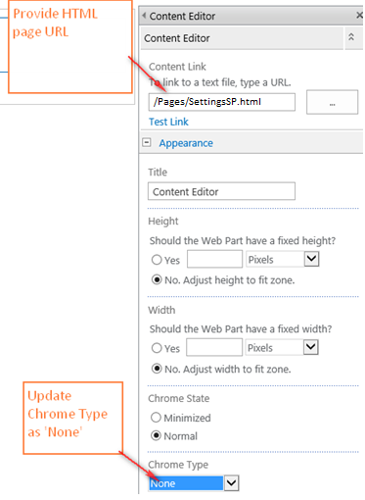

1. Click on ‘Save’ button
2. Select “Site Contents” and then select “Site Pages” as shown below:



1. Click on “…” icon on “Settings.aspx” row as shown below:

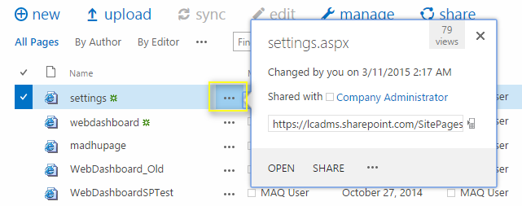

1. In the fly out that opens, click on “…” and then select “Shared With” as shown below:

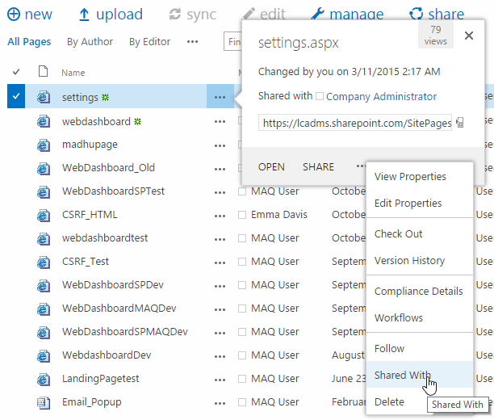

1. In the popup that opens up, select “Advanced” as shown below:

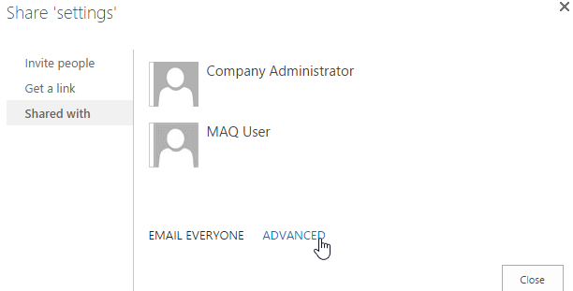

1. In the page that opens up, click on “Stop Inheriting Permissions”

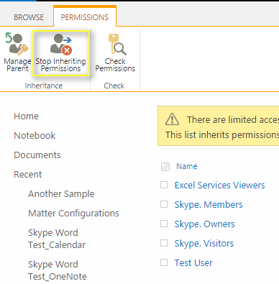

1. Remove the permissions of all the users/groups except for “Owners group” as shown below:

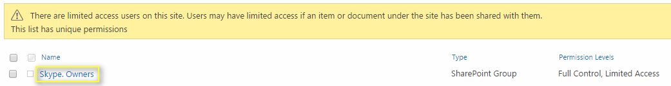

1. Steps for Provisioning Settings page at Tenant level:

For provisioning the Setting page at Tenant level, perform the step no. 4 similarly

**Settings list configurations**

1. Create configurations list by following below steps:

* Go to “Site Contents”:



* Click on “add an app, in the page that opens up Select “Custom list” as shown below:

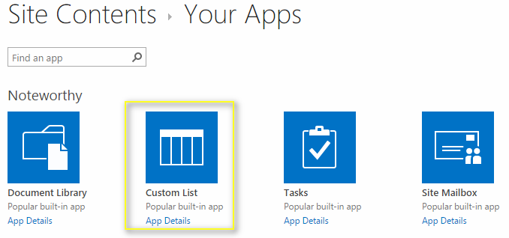

* Provide the name as “Matter Configurations” as shown below:

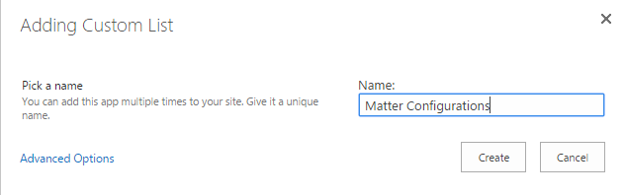

* In the page that opens up, click on “List” tab on the top and select “Create Column” as shown below:

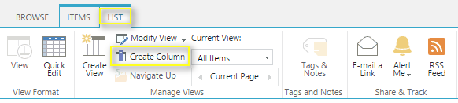

* In the popup that opens up, enter “ConfigurationValue” and Select “Multiple lines of text” and click on Ok button as shown below:

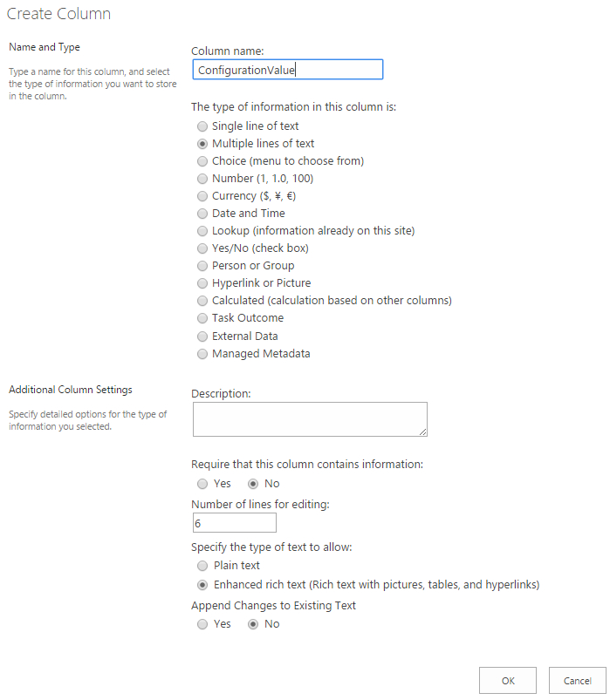

* Go to “List Settings” from the “List” tab and select “Permissions for this list” as shown below:

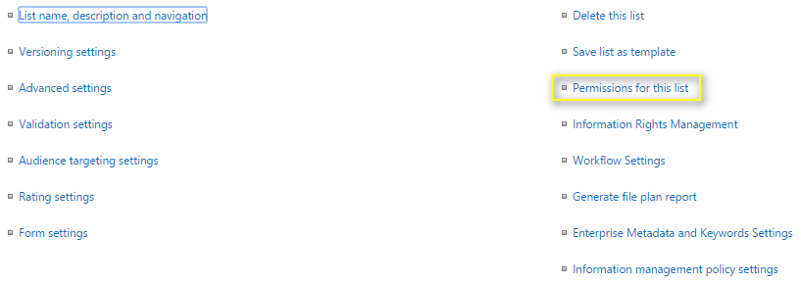

* In the page that opens up, click on “Stop Inheriting Permissions” and in the alert box click on “Ok” button as shown below:



* Change the permissions to “Read” of all the groups/users except for Owners group as shown below:

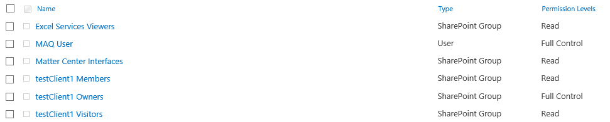

* Verify that settings page is loading fine

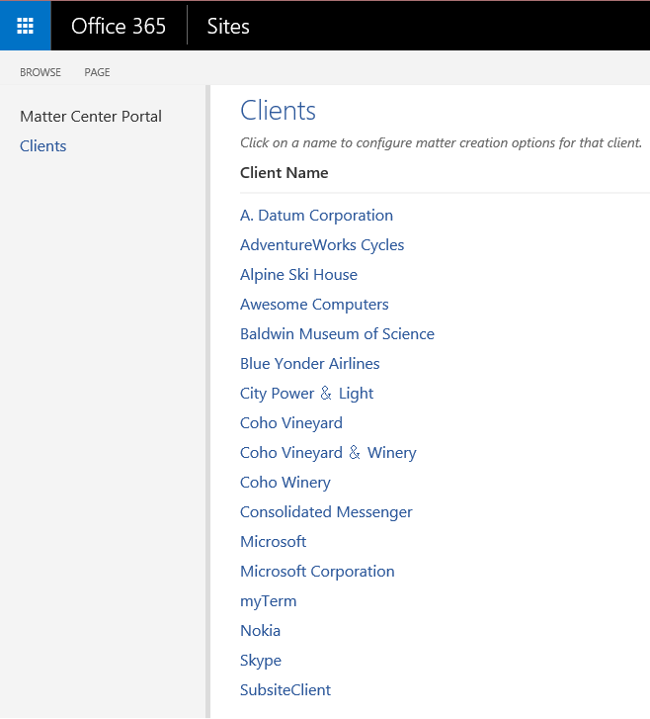

**Note**: We cannot hide a SharePoint list which is created using UI

# Appendix B

## Publish Content types from Content Type Hub

1. Go to Content type hub site collection, by using the following url: https://<tenant>/sites/contentTypeHub
2. For e.g. <https://myexampletenant.sharepoint.com/sites/contentTypeHub>
3. Go to Site Settings > Site Content types as shown below:

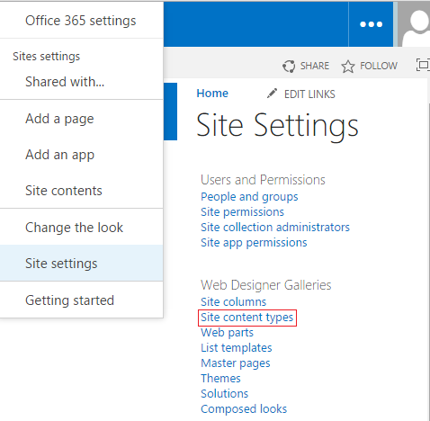

1. In the page that opens up, there will be a group called _MatterCenter as shown below:

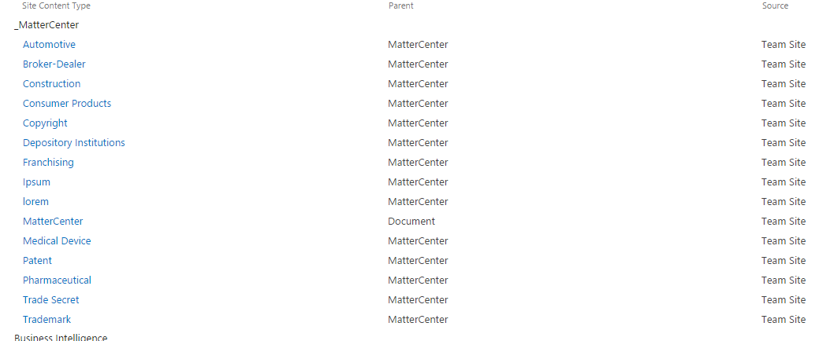

1. For each content type, click the link, choose the Manage publishing for this content type and select ok to publish the content type. Content types can take between 1-48 hours to publish to all the site collection. To verify the publishing is complete, go to the site collection you would like to create a matter on, click Settings > Site Content Types and verify that the _MatterCenter group and the content types are listed there.

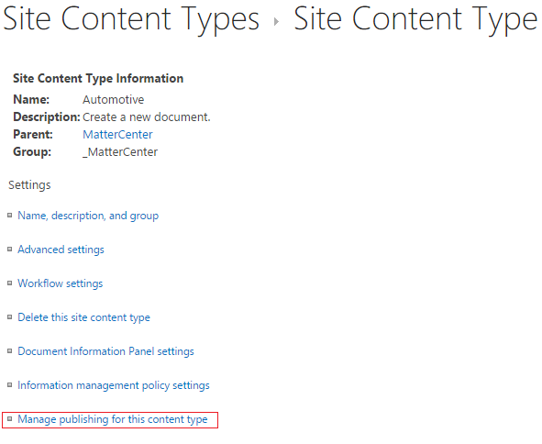

# Appendix C

## Add admin account to term store admin

1. Go to Admin center by typing the following URL in the browser: https://<tenant>-admin.sharepoint.com
2. For e.g. <https://mysharepointtenant-admin.sharepoint.com>
3. Select “term store” from the left navigation menu



1. Select “Taxonomy” node and in the Term Store Administrators, add the admin account as shown below:

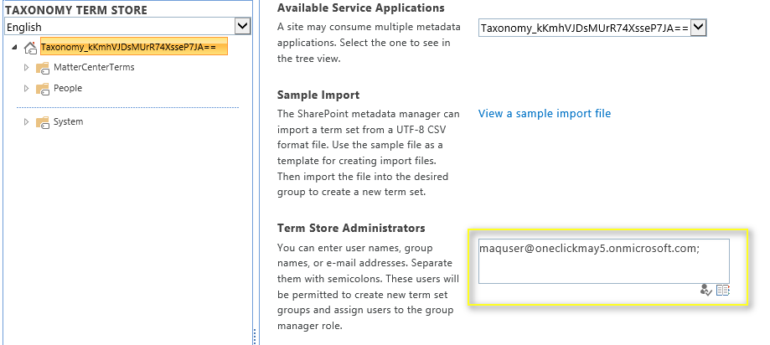

1. Click on Save button

# Troubleshooting Deployment Issues

* 1. Failed to install Exchange app

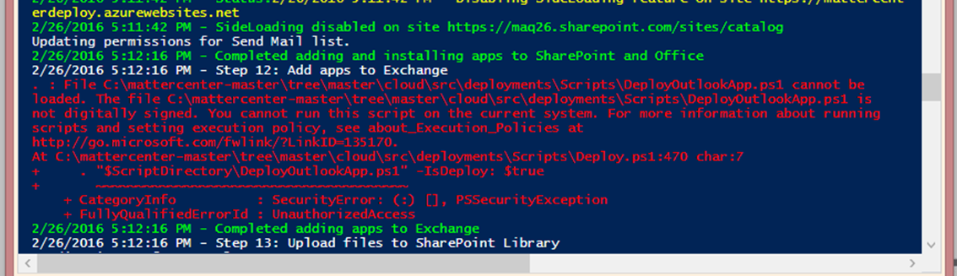

Resolution: Setup Outlook account of the user of which exchange credentials are used during deployment.